The rise and fall of OTA’s
Is Expedia Destined for Disruption

Travel and Tourism accounted for approximately $8 Trillion of the world economy in 2018 and 10% of the worlds work force a 6% increase from 2017 and no foreseeable signs of slowing. The travel industry is directly tied to global consumption growth and as wealth and populations continue to grow, demand for travel products will continue to expand. With statistics like this it should come as no supersize that there is a rush to jump into the market, the industry has a long history of failing to drive change and transform internally. “The travel and hospitality industry as a whole has taken a lot of criticism for its inability to drive innovation from within,” — Lio Chen Managing Director of Plug and Play Travel. But this may be about to change, many of the major players have begun taking notice and since 2008 the “travel-tech” sector has attracted over $19B+ in investments and with Amazon and Google both deciding to step back into the industry these numbers are only going to grow. While it’s been slow moving Travel Tech is likely on the verge of bringing T&T into the modern era. Plug and Play has a vertical dedicated to travel startups, Airbnb is only the first in a series of tech companies to start disrupting the status quo. The market is prime for disruption as personalization, AI and Blockchain are all integrated into what will be a new era of tech innovation.
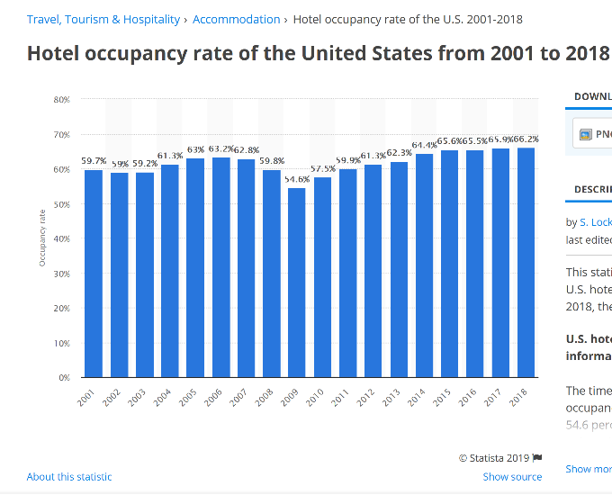
The first real taste the industry has had of disruption has been the introduction of Airbnb. There is no doubt that Airbnb has changed the way people travel however, Airbnb was a low-end and/or new market disruptor introducing an underserved population to the possibility of travel. While they have had an impact on hotels its arguably been larger in the housing sector than hotels. US Occupancies and ADR continue to grow even with Airbnb’s introduction. Before Airbnb the last major disruptor to the industry was two decades ago when Expedia stepped onto the scene and OTA’s changed everything. Prior to Expedia, hotels needed to rely on the GDS and to distribute rooms and rates and a traveler had few options other than a travel agent to assist in booking rooms. Not only did OTA’s cause a complete upheaval of how to book they also sent shockwaves to the bottom-line of hotels.
Before getting to where our industry is headed it’s important to have a basic understanding of the emerging technologies trends that will shape where tech is headed. AI, Blockchain, Big Data, Cyrpto and the current hot topic of personalization in travel are probably the top contenders at this moment in time. While its impossible to know exactly how each of these will ultimately play in the future of travel it’s safe to assume that these buzz words are not going anyplace in the years to come.
Blockchain: The travel and hospitality sector are infamously segmented. Blockchain will allow for seamless payments & customer service across different travel suppliers with drastically better security.
Predictive Analytics & Machine Learning: Intelligent computing will help proactively give travelers what they want through recommendations, proactive customer service, assisting avoiding travel disruptions, and more.
AI: Artificial Intelligence. IBM’s Watson and Google’s Artificial intelligence engine are revolutionizing the uses for AI and making it affordable. With this AI is set to revolutionize the way travelers and industry workers interact further advancing the idea of personalized travel.
Big Data: Ask any DORM and they will tell you there is no shortage of data in the hotel industry. Given the size of the travel and hospitality sector and the vast amount of data that is processed by travel companies, it is obvious that big data analytics will continue to grow in importance in the sector.
One of the major sectors most at risk of disruption is distribution. It’s no secret that hotels resent the margins OTA’s charge and while interfaces are good enough there is a strong desire to move to a seamless world. In addition, the continuing new on security breaches will hopefully bring a push to security and payment methods that don’t put our info at risk. Changes in distribution and most likely commission models are clearly visible on the horizon. Just the fact that Amazon and Google are pushing into the market makes it clear that change is coming. The likelihood that these changes will disrupt the status quo is even more evident as you see emerging startups focusing on distribution through blockchain. This could be a boom for hotels and airlines (although I wouldn’t start modifying budgets) and at the same time be a major blow to the major OTA’s. Google ultimately has control of search and if hotels are able to work with startups that are able to get rooms to market with significantly lower commissions it’s easy to see how OTA’s may struggle with the disruptions ahead. There is a great deal of speculation over how Google and Amazon will impact distribution but we should keep track of how rising startups will reinvent how rooms are sold.
One of the very first disruptors of the travel distribution market was Expedia. Expedia Group originally founded in 1996 as Microsoft Expedia Travel Services in the United States has grown to a company that employs 22K people across its global network of brands which consist of 200+ travel booking sites. In 2018 Expedia accounted for 99.7B in Gross bookings accounting for 31% of bookings from the major online travel agencies (OTA’s) in 2018. This amounts to 11.2B in revenues for 2018 and a total of 352M room nights. The company boasts 2B+ monthly site views and 144M+ unique visitors monthly.
In an industry often criticized for its failure to embrace technology and change, Expedia has stood out for its abilities to drive innovation. In 2016 at the Expedia Partners Conference the CFO announced a goal of 100B in gross bookings by 2020 which for all purposes it hit in 2018. Along with the aggressive growth put forward Overstory, Expedia CFO, discussed the future of the company and the travel industry saying that Expedia growth will require an acute focus on the ever-shifting needs of customers and partners. “Navigating the change that’s ahead—technological change and new competition—there are three levers to plot a path: organic strategy—asking what we can do differently; acquisition; and partnerships,” Overstory said. “We continue to invest aggressively, but we’re changing the paradigm of what we believe our partnership should be. …Expedia is your partner in technology and innovation.” Within this Okerstrom dropped teasers of Expedia’s discussions in Silicon Valley with Google and Amazon. While 2016 may seem dated this quote represents a focus on a business model focused in disruptive strategy and it is for this reason that I chose to focus on Expedia.
Hotel companies are eager to find a replacement for commission-based models and blockchain will provide additional leverage to many companies to push back on OTA’s. The advantage that Expedia has, is that at its heart Expedia is as much tech company as it is OTA. The company has always been efficient leveraging its technology and there is no reason to think this will change. I don’t have an inside track to Expedia’s future plans but its evident that Expedia is ready for market disruption. The CFO has hinted at intentions to steer Expedia Group into a more prominent role as a tech company which will require a skate to a different profit model in the future. As competition increases in the OTA world profitability from commissions are destined to dwindle. The OTA’s recent battles with Hilton and Marriott to pull inventory due to commission structure is going to continue as startups increase competition. A smart disruption Strategy theory suggests that Expedia will continue to develop more services to its partners and a more personalized experience for consumers.
Expedia has the ability to become more modular over time leveraging their technology to lock hotel inventory and marketing dollars in for access. The company has already moved into a loosely structured revenue management system locking hotels that want to utilize their vast market data into contracts with increased availability and room night sales quotas to access the system. The company has also offered hotels in major markets to opt into marketing agreements that lower commissions and thus ease pressure on Directors of Revenue to lower cost. As companies are forced to fight for lower margins due to both low end and new market disruption Expedia Group has already started to move its model in anticipation of changes to the industry. I would expect Expedia will provide more and more services to its partners while continuing to increase personalization to its customers. Incumbents such as Priceline while offering lower margins are struggling in functionality and while the company has maintained an edge by purchasing more booking sites their technology and marketing lag far behind Expedia. The company’s CFO Okerstrom goes so far as to hint at conversations with Google and Amazon which will be an interesting play in dominance of the market. Travel Tech Verticals such as Plug and Play would continue to further accelerate Expedia Groups position as a leader in the industry.
OTA’s are destined for disruption but evidence suggests that Expedia will be pushing forward in the travel industry for the foreseeable future. If the OTA’s are able to move their profitability structure and continue to advance their technology its likely they aren’t going anyplace, but the world of distribution within travel and tourism is moving towards some major changes in the not so distant future. For more info on where tech is going its worthwhile to check out Plug and Plays Travel Vertical.

